After AWS account administration training, login to the AWS account.

**Steps to create a new AWS VM:**

1. Go to the aws account, and click on Launch Instance

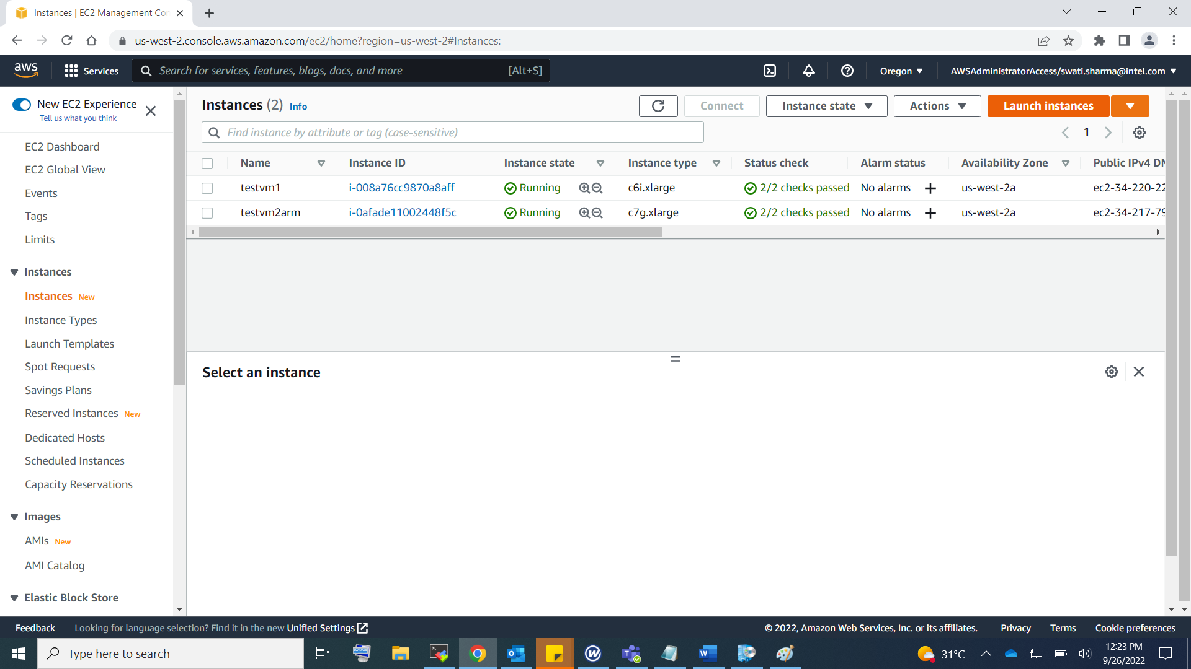

1. Name the instance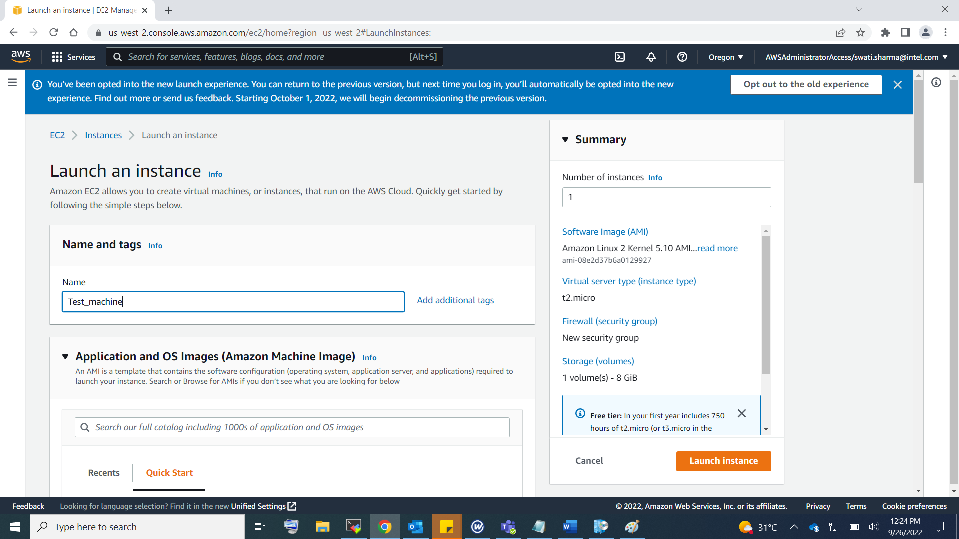
2. Select OS type image

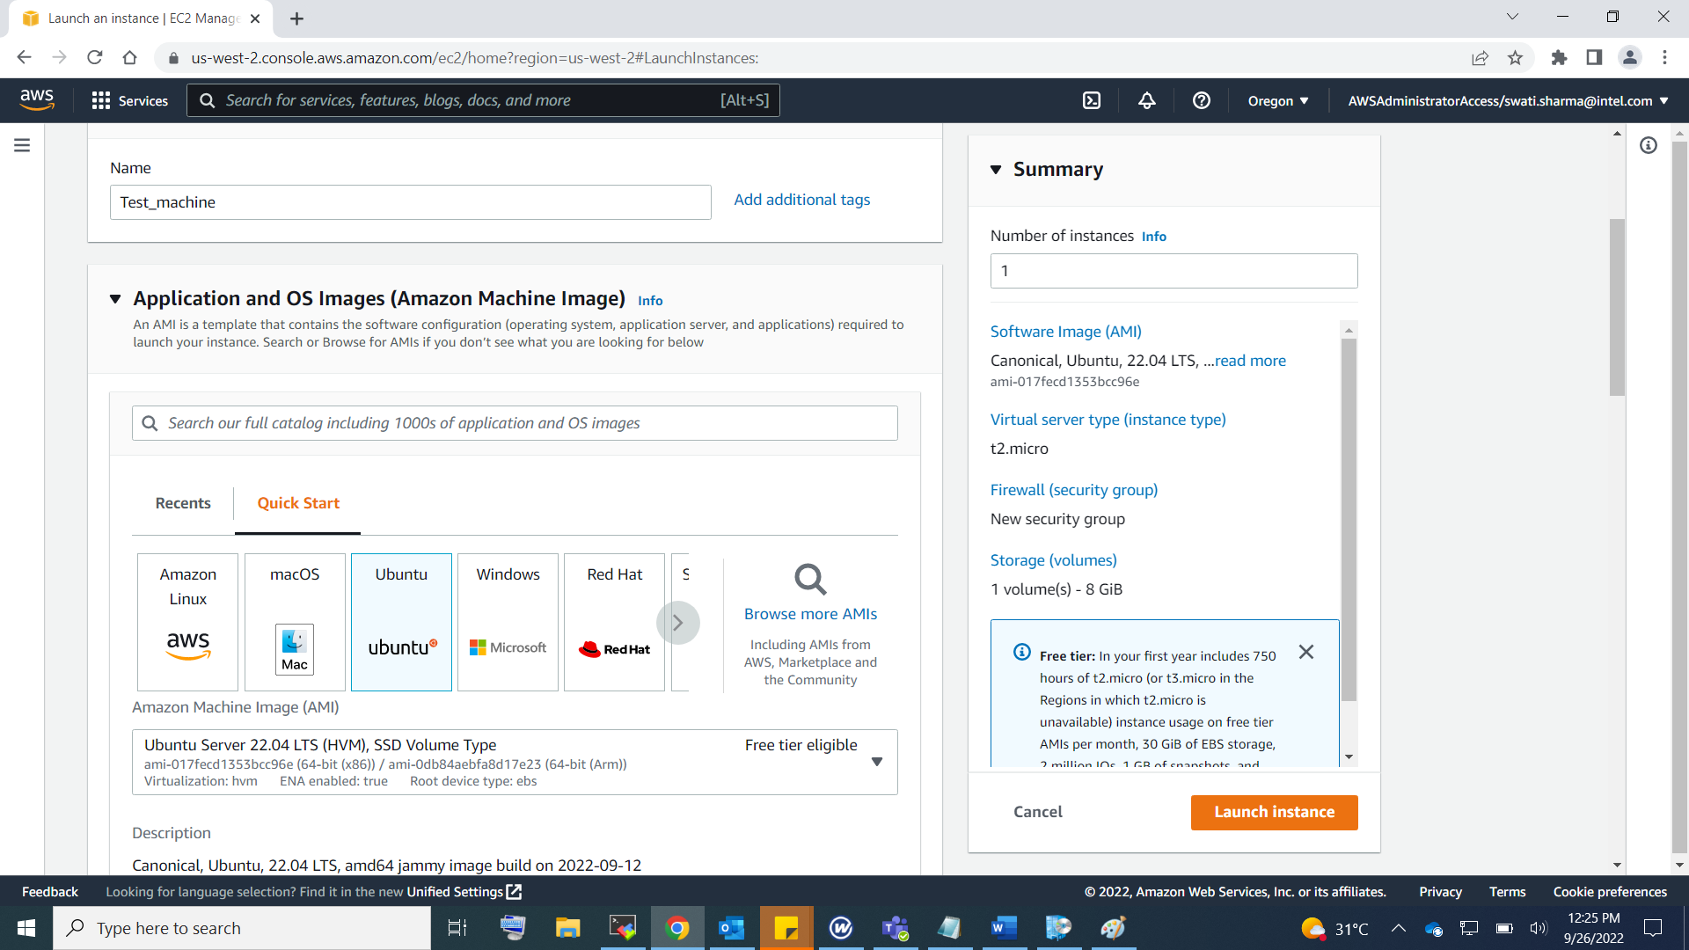

1. Choose Architecture

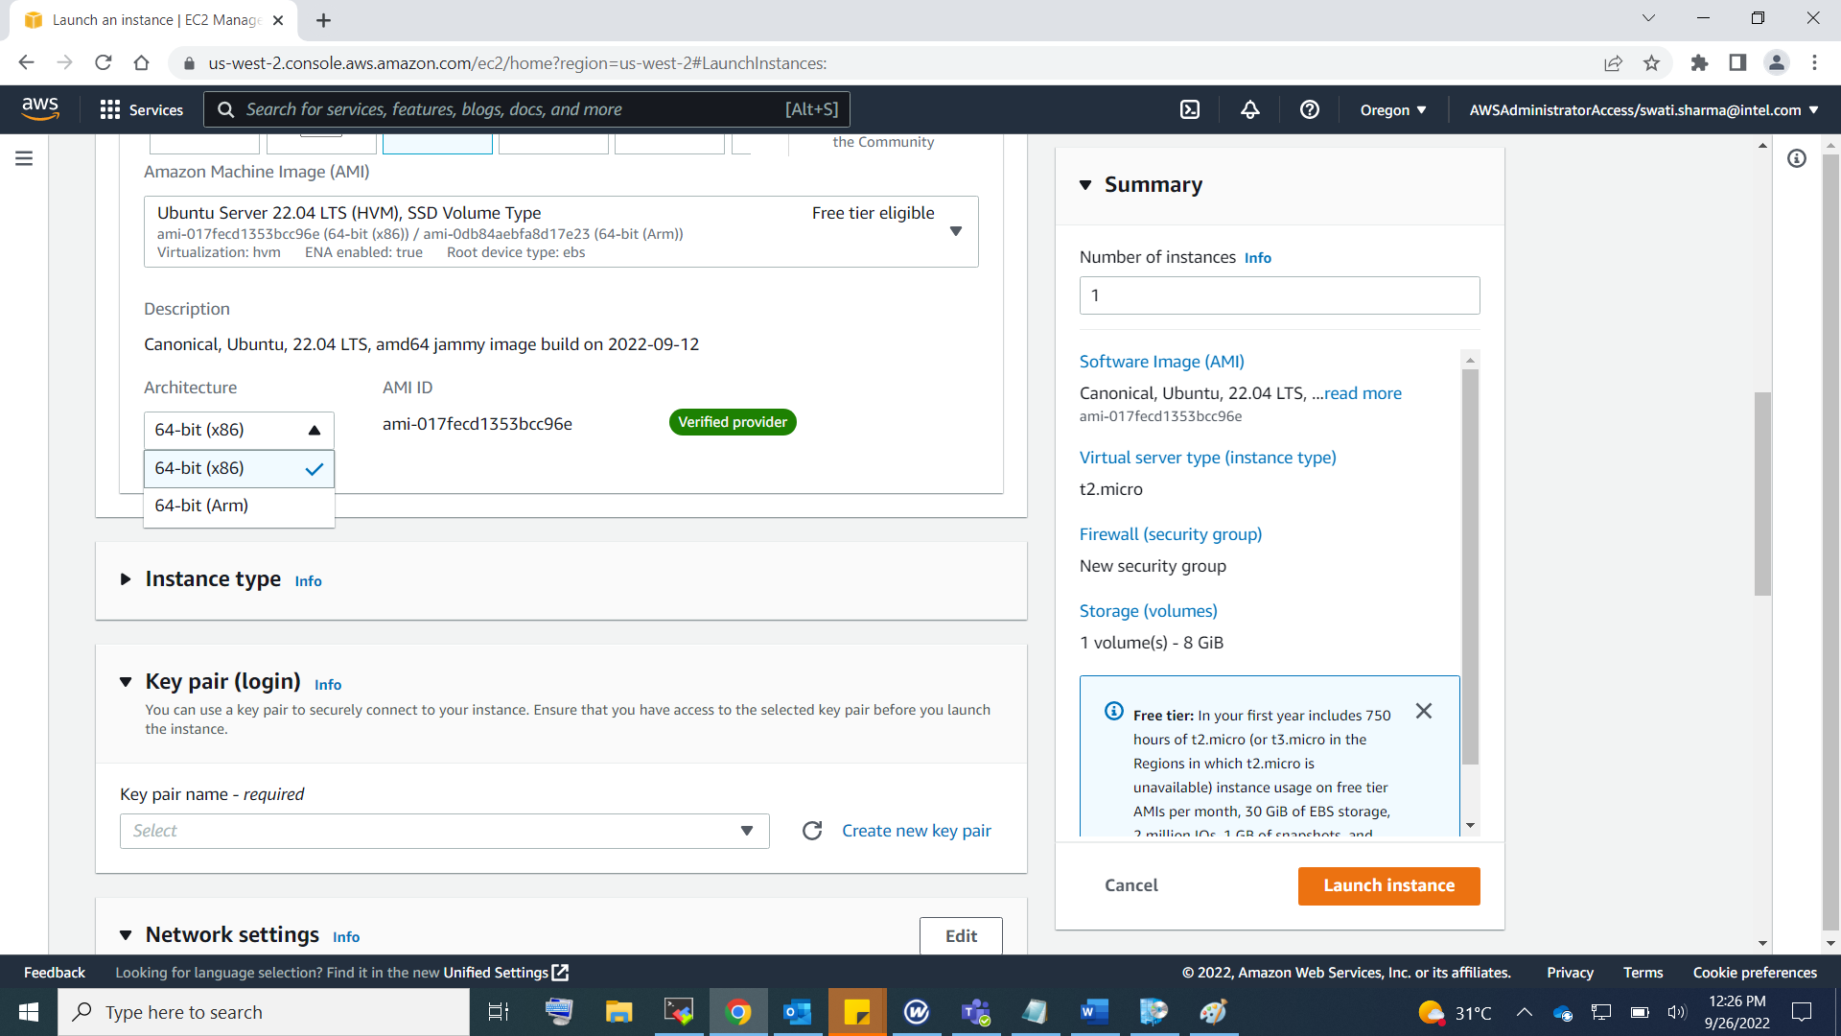

1. Choose Instance Type based on No of VPU’s and memory in GB

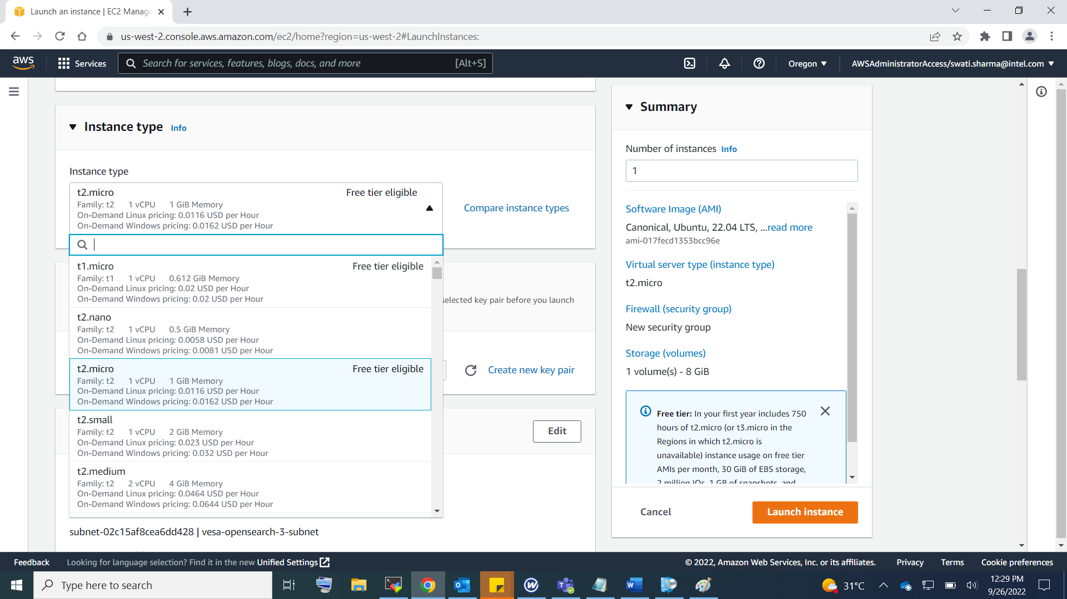

1. Create a new key pair, select .PPK file, we can later convert PPK file to PEM file using puttygen.

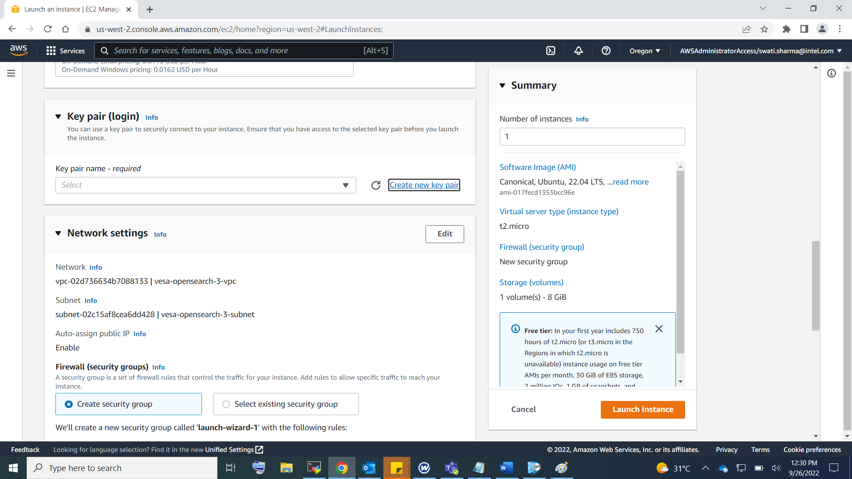

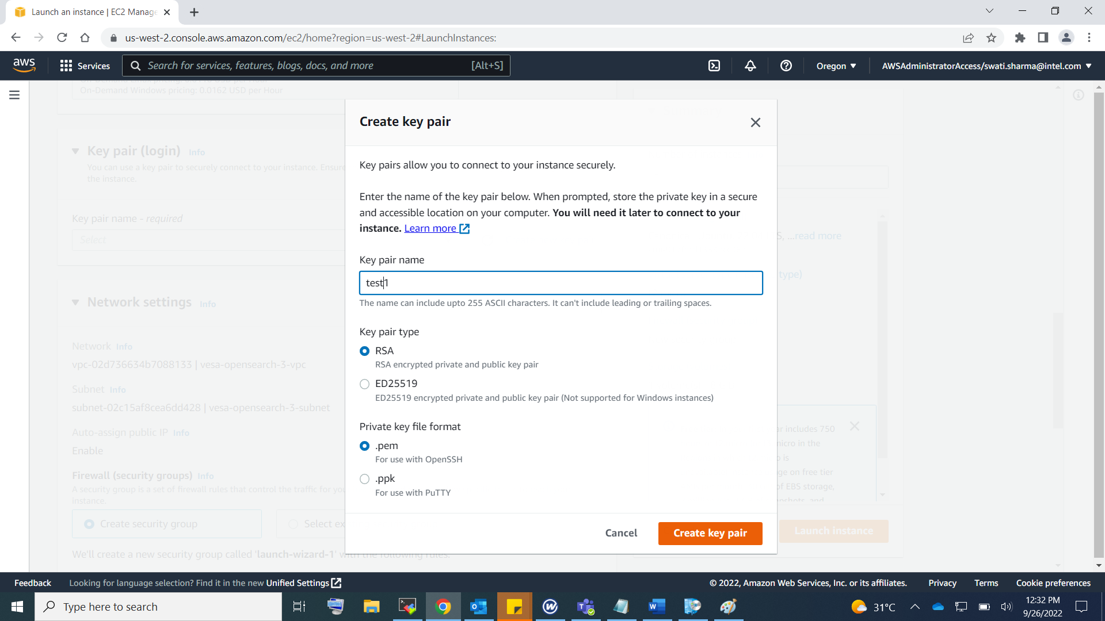

After the key pair will get downloaded on your system. Which will be needed during login.

1. After this can choose the network setting

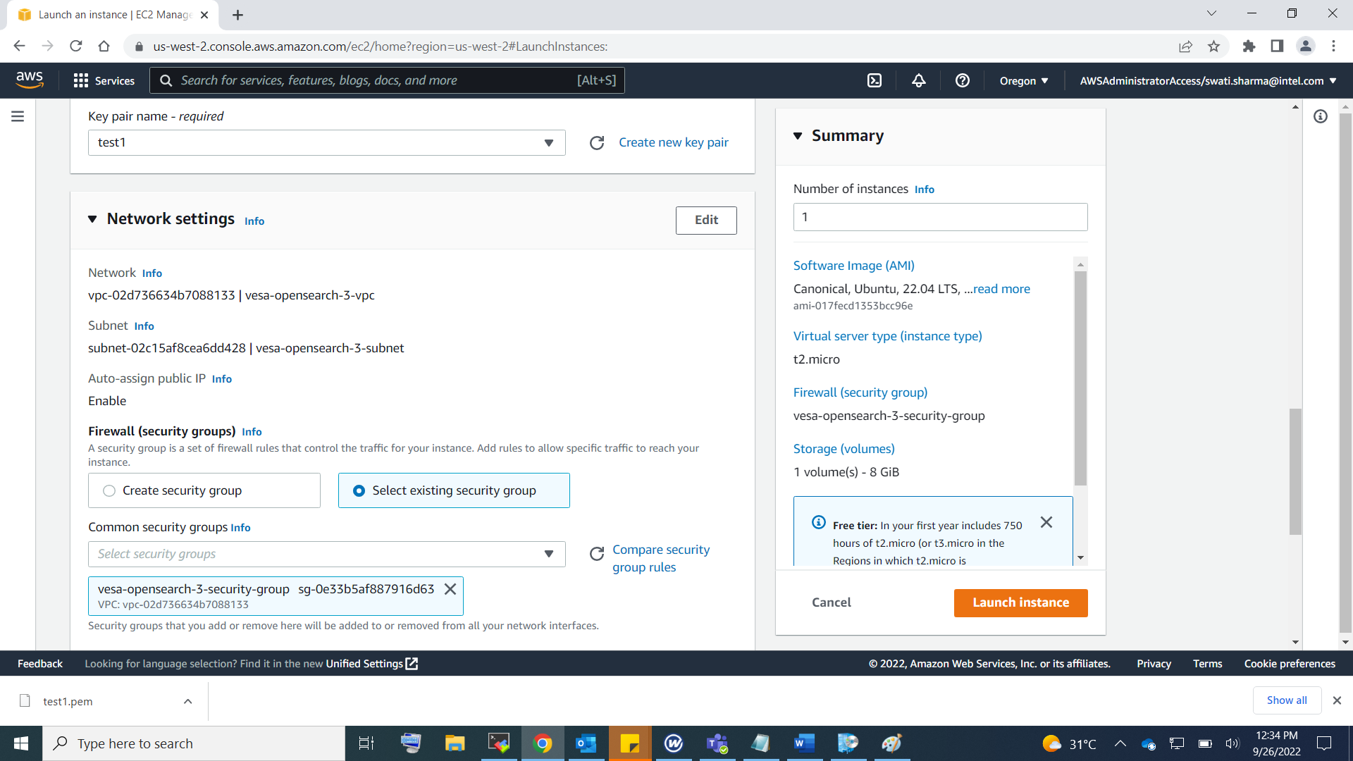

1. Can set the storage of system as per requirement

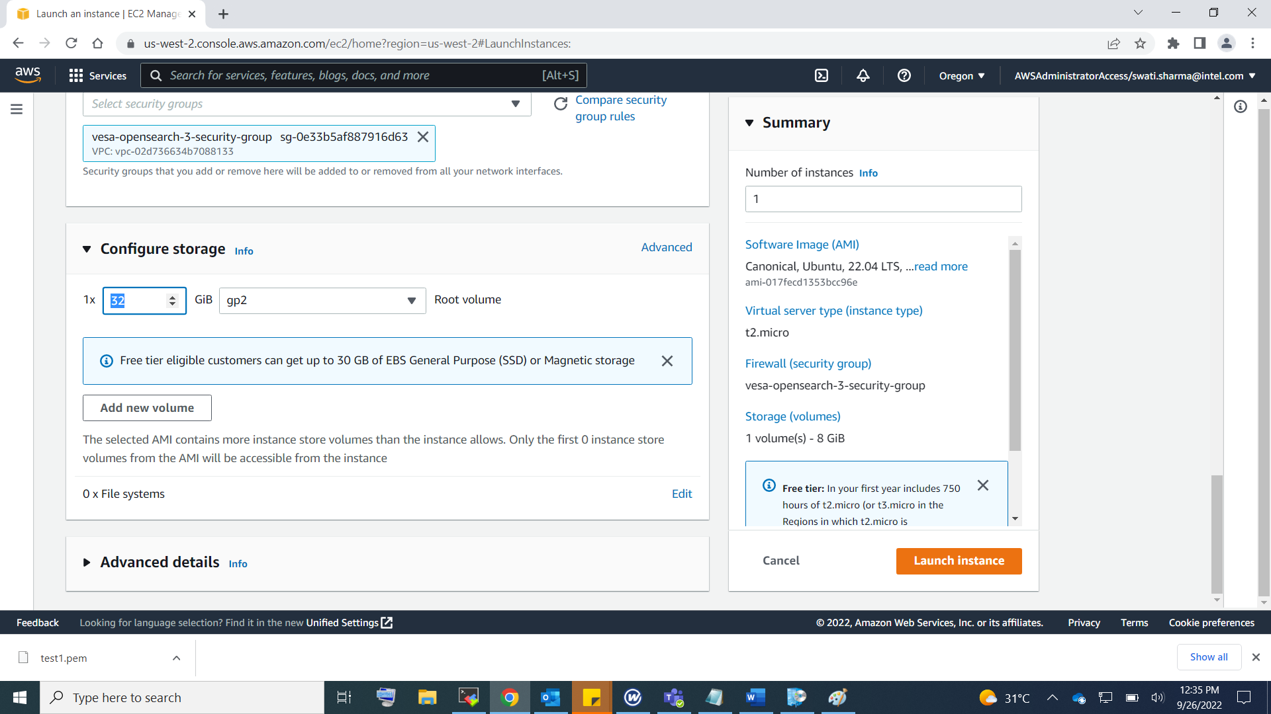

1. Launch the instance, this will create the instance, now to login follow the below steps

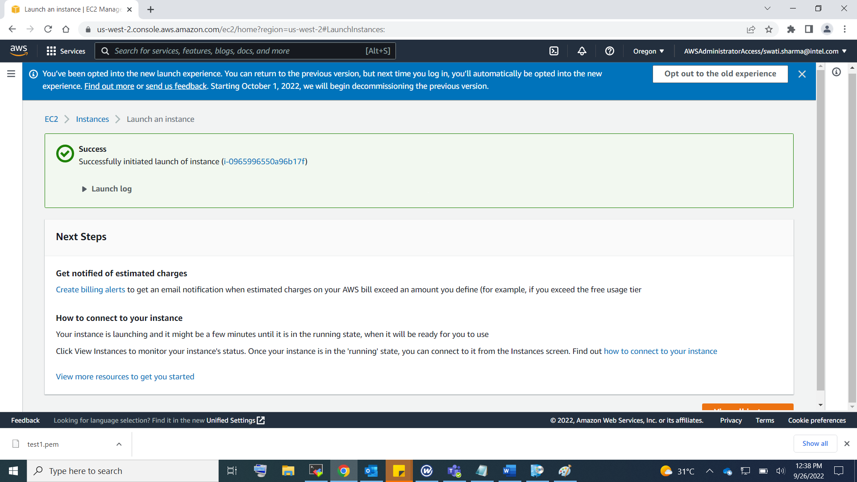

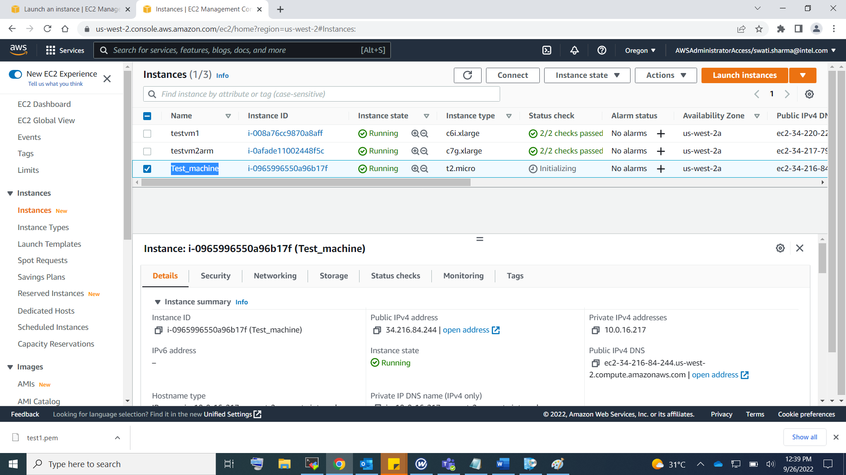

**Connecting an EC2 instance from lab machine:**

**Prerequisites:**

1. Convert the .PPK file to .PEM file using puttygen utility. Refer to following link for detailed instructions.

<https://aws.amazon.com/premiumsupport/knowledge-center/ec2-ppk-pem-conversion/>

1. Create an SSH config file with following contents. We use SOCKS5 proxies for connecting to instance using nc (net concatenation)

Host <user_specified_name>

User <EC2 VM instance username>

HostName <public_ip_of_ec2_instance>

IdentityFile “pem file”

Following is an example config file.

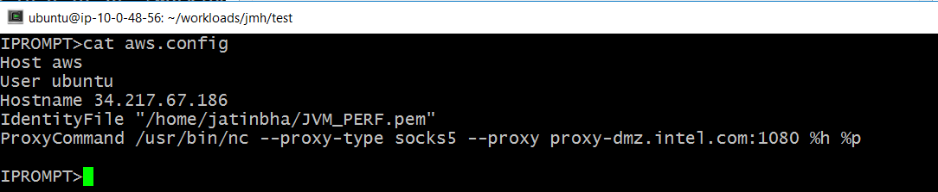

**Connect to EC2 instance from lab machine using ssh:**

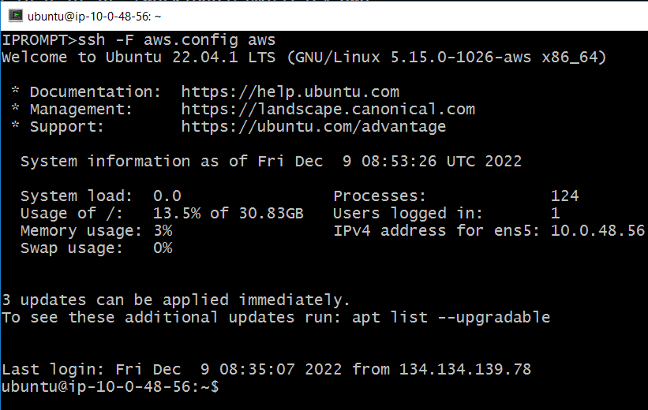

**Copy data from AWS instance using scp:**

